**Introduction to the Whitewater Rafting Website**

Joyce Keil

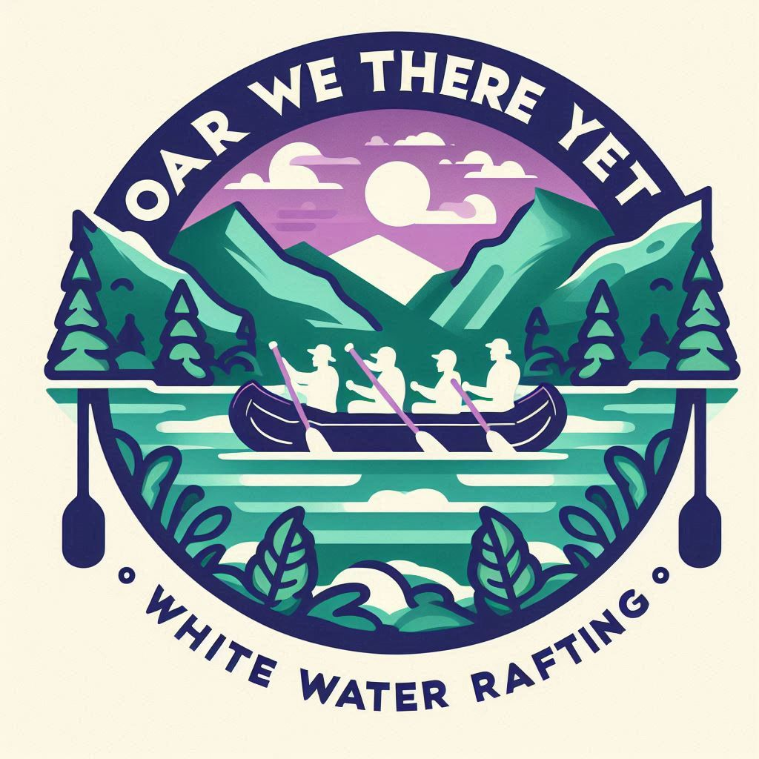

Primary-color: 373466

secondary-color: DFD6D6

ascent1-color: 1B5866

ascent2-color: AD70AD

heading-font: Delius Static

text-font: Sour Gummy

<https://coolors.co/ad70ad-dfd6d6-1b5866-373466>